SARCOIDOSIS VASCULITIS AND DIFFUSE LUNG DISEASES 2022; 39 (1); e2022003 DOI: 10.36141/svdld.v39i1.12526

Effect of a Telerehabilitation program in sarcoidosis
Jose Cerdan de las Heras ^{1, 2, 3}, Fernanda Balbino ³, Daniel Catalán-Matamoros ^{4, 5}, Anders Løkke ⁶, Ole Hilberg ⁶, Elisabeth Bendstrup ^{1, 7}
¹Department of Respiratory Diseases and Allergy, Aarhus University Hospital, Aarhus, Denmark
²Department of Clinical Research, Nordsjaellands Hospital, Hilleroed, Denmark
³Department of Research and Development, Physio R&D ApS, Frederiksberg, Denmark
⁴Department of Communication Studies, University Carlos III of Madrid, Madrid, Spain
⁵Health Research Institute, University of Almeria, Almeria, Spain
⁶Department of Respiratory Medicine, Vejle Hospital, Vejle, Denmark
⁷Department of Clinical Medicine, Aarhus University, Aarhus, Denmark

SUPPLEMENTARY FILES

Report 1 (The program for telerehabilitation) 2
Report 2 (Participants non participants) 4
Report 3 (Baseline data) 5
Report 4 (Follow up data) 8
Report 5 (Protocol for maximal isometric voluntary contraction in arm and leg) 18
Report 6 (6 minute walk test distance results occluding the 4 patients with scadding stage 0) 19

Report 1 (The program for telerehabilitation)
Table 1. The program for tele-rehabilitation. (From Cerdan et al)

Workout sessions with VAPA | The patients trained 10-20 minutes 3-5 times a week at home with their individual and tailored VAPA using training aids such as elastics, weights and a fitness-step to reach the highest workout intensity. The VAPA provided encouragement to keep on training during the workout.
Questionnaires | The patients filled out questionnaires regarding satisfaction, breathlessness, and adverse events reporting.
Video consultation sessions | Each patient met the physiotherapist in a video consultation to plan the rehabilitation program and to evaluate previous training experience.
Chat sessions | Allowed the patient to interact and get prompt answers from the physiotherapist
E-learning packages | The patient had access to e-learning packages addressing psychological, medical, nutritional and physical aspects of pulmonary chronic patients - in part supplied by relevant special data sources medicin.dk ³, lunge.dk ⁴ and helbredsprofilen.dk.⁵ or created by dietitian students after in-depth interviews with pulmonary patients^{6–9} .

References:
1. Cerdán-de-las-Heras J, Balbino F, Løkke A, Catalán-Matamoros D, Hilberg O, Bendstrup E. Tele-rehabilitation program in idiopathic pulmonary fibrosis—A single-center randomized trial. Int J Environ Res Public Health. 2021;18(19):10016.
2. Creative Commons — Attribution 4.0 International — CC BY 4.0. Accessed October 4, 2021. https://creativecommons.org/licenses/by/4.0/
3. medicin.dk – information om medicin. Accessed August 21, 2020. http://medicin.dk/
4. Lungeforeningen. Accessed August 21, 2020. https://www.lunge.dk/
5. Helbredsprofilen.dk. Accessed August 21, 2020. https://helbredsprofilen.dk/da
6. Spis rigtigt - Antiinflammatorisk kost - YouTube. Accessed August 26, 2020. https://youtube.com/embed/w5fjXI6NHec
7. Spis rigtigt - Frugt og grønt - YouTube. Accessed August 26, 2020. https://youtube.com/embed/5O479Caonrc
8. Råd til undervægtige - YouTube. Accessed August 26, 2020. https://youtube.com/embed/t1Haq6Gf5hA
9. Råd til overvægtige - YouTube. Accessed August 26, 2020. https://youtube.com/embed/UKdjxpVjqFA

Report 2 (Participants non participants)
Table 1. Demographic data at baseline for participants and non-participants.
There were no differences between participants and non-participants.

Variables | NON-PARTICIPANTS |  |  |  | PARTICIPANTS |  |  |  | P-value | Mean Difference
 | Mean |  | SD | n | Mean |  | SD | n
Age, years | 55.53 | ± | 13.52 | 17 | 53.87 | ± | 13.55 | 30 | 0.69 | 1.66
6MWTD, m* | 570 | ± | 0 | 1 | 513.1 | ± | 141.29 | 30 | 0.7 | 56.9
FVC, l** | 3.77 | ± | 1.12 | 16 | 3.79 | ± | 1.11 | 30 | 0.97 | -0.02
FVC predicted% | 84.35 | ± | 21.79 | 17 | 88.93 | ± | 18.83 | 30 | 0.45 | -4.58
DLCO*** | 9.47 | ± | 1.78 | 17 | 9.47 | ± | 1.96 | 25 | 1 | 0
DLCO Predicted% | 69.53 | ± | 16.21 | 17 | 65.24 | ± | 16.09 | 25 | 0.4 | 4.29
Male/female | 13 male / 4 female |  |  |  | 19 male / 11 female
* 6 Minute Walk Test Distance. ** Forced Vital Capacity *** Diffusing capacity for Carbon Monoxide

Report 3 (Baseline data)
Table 1. Baseline demographics of all randomised patients.

Variable |  | All n=30
Male, n (%) |  | 19 (63.33%)
Age (years), mean (SD) |  | 53.87 (13.55)
Weight (kg), mean (SD) |  | 87.90 (20.15)
Height (cm) mean (SD) |  | 173.93(9.89)
BMI mean (height2/weight) (SD) |  | 29.08 (6.51)
Scadding stage (radiological stadium) | 0 | 7
 | 1 | 3
 | 2 | 4
 | 3 | 3
 | 4 | 11
Corticosteroid treatment |  | 13
Immunomodulatory treatment* |  | 8
Smoking status  Current, n (%) |  | 1
Former, n (%) |  | 8
Never, n (%) |  | 19
FVC (% predicted), mean (SD) |  | 88.93 (18.83)
DLCO (% predicted), mean (SD) |  | 65.24 (16.09)
6MWTD (m), mean (SD) |  | 513.1 (141.3)
MVC arm & leg total mean (SD) |  | 16.34(30)
7 days pedometry mean (SD) |  | 15978.54 (9338.84)
SGRQ-I total mean (SD) |  | 35.05 (21.86)
KBILD total mean (SD) |  | 60.57 (10.75)
GAD7 mean (SD) |  | 2.97 (4.65)
SD: Standard deviation; FVC: Forced vital capacity; DLCO: Diffusion capacity for carbon monoxide; 6MWTD: 6 minute walk test distance; MVC arm & leg total: maximal isometric voluntary contraction in arm and leg ;7 days pedometry: steps walked in 7 days; SGRQ: Saint George Respiratory Questionnaire; KBILD: King's Brief Interstitial Lung Disease Questionnaire; GAD7: General Anxiety Disorder-7 Questionnaire.

Table 2. Baseline demographics in the control and intervention group.

 |  | CONTROL |  |  |  | INTERVENTION |  |  |  | P-value* | Mean Difference
 |  | Mean |  | SD | n | Mean |  | SD | n
Pulmonary function | FVC% | 84.73 | ± | 17.93 | 15 | 93.13 | ± | 19.38 | 15 | 0.23 | 8.40
 | DLCO% | 64.30 | ± | 17.18 | 10 | 65.87 | ± | 15.91 | 15 | 1.57 | 0.82
Physical performance | 6MWTD, m | 527.53 | ± | 163.48 | 15 | 498.67 | ± | 119.07 | 15 | -28.87 | 0.58
 | 7dVMCPM | 490.08 | ± | 240.47 | 15 | 561.67 | ± | 242.92 | 13 | 0.44 | 71.59
 | 7 days pedometry | 14,282.80 | ± | 7,515.58 | 15 | 17,935.15 | ± | 11,072.10 | 13 | 0.31 | 3,652.35
 | MVC arm & leg total | 16.43 |  | 4.61 | 15 | 16.26 |  | 5.03 | 15 | 0.925 | 0.168
Quality of Life | SGRQ total | 31.03 | ± | 21.69 | 15 | 39.08 | ± | 22.02 | 15 | 0.32 | 8.05
 | KBILD total | 62.00 | ± | 9.77 | 15 | 59.13 | ± | 11.82 | 15 | 0.47 | -2.87
 | GAD7 | 1.73 | ± | 3.105 | 15 | 4.20 | ± | 5.647 | 15 | 0.15 | 2.47
* Independent t-test equal variances assumed
SD: Standard deviation; FVC: Forced vital capacity; DLCO: Diffusion capacity for carbon monoxide; 6MWTD: 6 minute walk test distance; MVC arm & leg total: maximal isometric voluntary contraction in arm and leg (kilogram-force (kgf)); HR: Heart rate; 7dVMCPM: 7 days vector magnitude counts per minute; SGRQ: Saint George Respiratory Questionnaire; KBILD: King's Brief Interstitial Lung Disease Questionnaire; GAD7: General Anxiety Disorder-7 Questionnaire.

Report 4 (Follow up data)
Follow up data
The control and intervention group were analyzed comparing the baseline data with data obtained after 3 months (end of rehabilitation), 6 months and 9 months.

Control group
Table 1: Changes over time in pulmonary function, physical performance, physical activity, exercise recovery and quality of life in the control group.
 | Baseline |  |  | 3 months |  |  | 6 months |  |  | 9 months |  |  | p-value
 |  |  |  |  |  |  |  |  |  |  |  |  | BL-3M
 |  |  |  |  |  |  |  |  |  |  |  |  | BL-6M
 | Mean |  | SD | Mean |  | SD | Mean |  | SD | Mean |  | SD | BL-9M
FVC, percent predicted |  |  |  |  |  |  |  |  |  |  |  |  | 0.48
 | 82.79 | ± | 16.88 | 84.29 | ± | 16.07 | 87.09 | ± | 16.53 | 3.75 | ± | 1.08 | 0.37
 |  |  |  |  |  |  |  |  |  |  |  |  | 0.28
DLCO, percent predicted |  |  |  |  |  |  |  |  |  |  |  |  | 0.84
 | 72.00 | ± | 9.57 | 71.60 | ± | 10.24 | 69.57 | ± | 14.91 | 65.75 | ± | 13.50 | 0.68
 |  |  |  |  |  |  |  |  |  |  |  |  | 0.12
6MWTD, m |  |  |  |  |  |  |  |  |  |  |  |  | 0.82
 | 546.46 | ± | 140.96 | 541.54 | ± | 108.64 | 528.27 | ± | 129.04 | 498.10 | ± | 99.99 | 0.59
 |  |  |  |  |  |  |  |  |  |  |  |  | 0.43
7 days pedometry (steps) |  |  |  |  |  |  |  |  |  |  |  |  | 0.54
 | 14,282.80 | ± | 7,515.58 | 14,245.00 | ± | 6,551.92 | 17,024.86 | ± | 9,042.45 | 13,094.40 | ± | 7,435.27 | 0.79
 |  |  |  |  |  |  |  |  |  |  |  |  | 0.25
7 d VMCPM |  |  |  |  |  |  |  |  |  |  |  |  | 0.10
 | 490.08 | ± | 240.47 | 423.00 | ± | 162.36 | 557.26 | ± | 256.61 | 433.59 | ± | 237.41 | 0.80
 |  |  |  |  |  |  |  |  |  |  |  |  | 0.33
MVC arm & leg total |  |  |  |  |  |  |  |  |  |  |  |  | 0.79
 | 16.43 | ± | 4.61 | 15.99 | ± | 8.11 | 15.91 | ± | 6.49 | 13.78 | ± | 7.78 | 0.75
 |  |  |  |  |  |  |  |  |  |  |  |  | 0.24
SGRQ total |  |  |  |  |  |  |  |  |  |  |  |  | 0.66
 | 27.86 | ± | 18.56 | 28.69 | ± | 20.23 | 31.66 | ± | 20.29 | 32.58 | ± | 21.15 | 0.43
 |  |  |  |  |  |  |  |  |  |  |  |  | 0.0.87
KBILD total |  |  |  |  |  |  |  |  |  |  |  |  | 0.08
 | 63.06 | ± | 9.23 | 66.60 | ± | 11.88 | 61.85 | ± | 9.98 | 67.98 | ± | 15.58 | 0.91
 |  |  |  |  |  |  |  |  |  |  |  |  | 0.25
GAD-7 |  |  |  |  |  |  |  |  |  |  |  |  | 0.17
 | 1.71 | ± | 3.22 | 2.79 | ± | 5.21 | 3.55 | ± | 5.84 | 2.10 | ± | 2.56 | 0.10
 |  |  |  |  |  |  |  |  |  |  |  |  | 0.25

SD: Standard deviation; FVC: Forced vital capacity; DLCO: Diffusion capacity for carbon monoxide; 6MWTD: 6 minute walk test distance; HR: Heart rate; 7dVMCPM: 7 days vector magnitude counts per minute; SGRQ: Saint George Respiratory Questionnaire; KBILD: King's Brief Interstitial Lung Disease Questionnaire; GAD7: General Anxiety Disorder-7 Questionnaire.

Intervention group
Table 2: Change over time in pulmonary function, physical performance, physical activity, exercise recovery and quality of life in the intervention group.
 | Baseline |  |  | 3 months |  |  | 6 months |  |  | 9 months |  |  | p-value
 |  |  |  |  |  |  |  |  |  |  |  |  | BL-3M
 |  |  |  |  |  |  |  |  |  |  |  |  | BL-6M
 | Mean |  | SD | Mean |  | SD | Mean |  | SD | Mean |  | SD | BL-9M
FVC, percent predicted |  |  |  |  |  |  |  |  |  |  |  |  | 0.18
 | 96.40 | ± | 19.10 | 94.00 | ± | 17.82 | 74.00 | ± | 15.90 | 95.22 | ± | 18.52 | 0.28
 |  |  |  |  |  |  |  |  |  |  |  |  | 0.48
DLCO, percent predicted |  |  |  |  |  |  |  |  |  |  |  |  | 0.72
 | 59.00 | ± | 13.62 | 58.40 | ± | 12.93 | 65.50 | ± | 16.13 | 69.67 | ± | 16.73 | 0.75
 |  |  |  |  |  |  |  |  |  |  |  |  | 0.24
6MWTD, m |  |  |  |  |  |  |  |  |  |  |  |  | 0.04
 | 547.80 | ± | 102.8 | 567.3 | ± | 103.6 | 576.67 | ± | 113.71 | 575.44 | ± | 139.44 | 0.03
 |  |  |  |  |  |  |  |  |  |  |  |  | 0.08
7 days pedometry (steps) |  |  |  |  |  |  |  |  |  |  |  |  | 0.47
 | 17,935.15 | ± | 11,072.10 | 16,780.33 | ± | 5,100.98 | 16,023.14 | ± | 4,681.509 | 16,609.14 | ± | 8,454.35 | 0.37
 |  |  |  |  |  |  |  |  |  |  |  |  | 0.97
7 d VMCPM |  |  |  |  |  |  |  |  |  |  |  |  | 0.35
 | 561.67 | ± | 242.92 | 537.07 | ± | 160.54 | 497.54 | ± | 81.87 | 484.64 | ± | 202.22 | 0.21
 |  |  |  |  |  |  |  |  |  |  |  |  | 0.18
MVC arm & leg total |  |  |  |  |  |  |  |  |  |  |  |  | 0.06
 | 16.26 | ± | 5.03 | 10.73 | ± | 9.6 | 16.4 | ± | 7.71 | 19.31 | ± | 7.26 | 0.81
 |  |  |  |  |  |  |  |  |  |  |  |  | 0.11
SGRQ total |  |  |  |  |  |  |  |  |  |  |  |  | 0.41
 | 34.86 | ± | 23.89 | 31.91 | ± | 23.18 | 28.06 | ± | 22.51 | 25.44 | ± | 17.91 | 0.55
 |  |  |  |  |  |  |  |  |  |  |  |  | 0.24
KBILD total |  |  |  |  |  |  |  |  |  |  |  |  | 0.01
 | 61.79 | ± | 11.15 | 68.91 | ± | 14.20 | 56.56 | ± | 11.31 | 67.37 | ± | 11.14 | 0.33
 |  |  |  |  |  |  |  |  |  |  |  |  | 0.36
GAD-7 |  |  |  |  |  |  |  |  |  |  |  |  | 0.75
 | 2.90 | ± | 4.43 | 2.70 | ± | 3.13 | 1.67 | ± | 2.00 | 0.56 | ± | 0.73 | 0.85
 |  |  |  |  |  |  |  |  |  |  |  |  | 0.05

SD: Standard deviation; FVC: Forced vital capacity; DLCO: Diffusion capacity for carbon monoxide; 6MWTD: 6 minute walk test distance; HR: Heart rate; 7dVMCPM: 7 days vector magnitude counts per minute; SGRQ: Saint George Respiratory Questionnaire; KBILD: King's Brief Interstitial Lung Disease Questionnaire; GAD7: General Anxiety Disorder-7 Questionnaire.

Differences between groups
Table 3. Differences between the control and intervention groups in pulmonary function, physical performance, physical activity, exercise recovery and quality of life after treatment and follow-ups.
 | Mean Difference | Std Error Difference | Mean Difference | Std Error Difference | Mean Difference | Std Error Difference | p-value
 |  |  |  |  |  |  | 3M
 | 3M |  | 6M |  | 9M |  | 6M
 |  |  |  |  |  |  | 9M
FVC, percent predicted |  |  |  |  |  |  | 0.18
 | 9.71 | 6.96 | -10.24 | 7.51 | 0.34 | 0.46 | 0.19
 |  |  |  |  |  |  | 0.47
DLCO percent predicted |  |  |  |  |  |  | 0.03
 | -17.6 | 6.82 | 3.70 | 7.25 | 0.47 | 0.77 | 0.62
 |  |  |  |  |  |  | 0.55
6MWTD, m |  |  |  |  |  |  | 0.57
 | 25.76 | 44.80 | 48.39 | 55.04 | 77.34 | 55.22 | 0.39
 |  |  |  |  |  |  | 0.18
7 days pedometry (steps) |  |  |  |  |  |  | 0.36
 | 2,535.33 | 3,848.60 | -1,001.71 | 3,534.35 | 3,514.74 | 3,872.85 | 0.80
 |  |  |  |  |  |  | 0.38
7 d VMCPM |  |  |  |  |  |  | 0.14
 | 114.067 | 74.206 | -59.714 | 101.804 | 51.0529 | 110.3861 | 0.57
 |  |  |  |  |  |  | 0.65
MVC arm & leg total |  |  |  |  |  |  | 0.12
 | 5.256 | 3.259 | -0.486 | 3.027 | -5.527 | 3.338 | 0.874
 |  |  |  |  |  |  | 0.114
SGRQ total |  |  |  |  |  |  | 0.72
 | 3.22 | 8.90 | -3.60 | 9.58 | -4.50 | 7.87 | 0.71
 |  |  |  |  |  |  | 0.58
KBILD total |  |  |  |  |  |  | 0.67
 | 2.31 | 5.33 | -4.25 | 4.51 | 2.29 | 8.80 | 0.36
 |  |  |  |  |  |  | 0.80
GAD-7 |  |  |  |  |  |  | 0.96
 | -0.09 | 1.85 | -1.88 | 2.05 | -7.14 | 9.05 | 0.37
 |  |  |  |  |  |  | 0.44

SD: Standard deviation; FVC: Forced vital capacity; DLCO: Diffusion capacity for carbon monoxide; 6MWTD: 6 minute walk test distance; HR: Heart rate; 7dVMCPM: 7 days vector magnitude counts per minute; SGRQ: Saint George Respiratory Questionnaire; KBILD: The King's Brief Interstitial Lung Disease Questionnaire; GAD7: General Anxiety Disorder-7 Questionnaire.

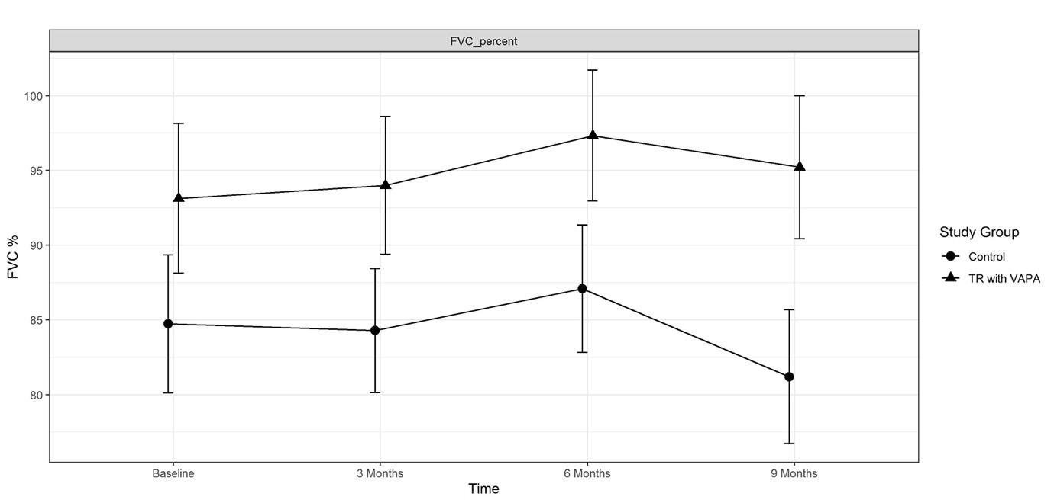
Figure 1. Mean FVC percent predicted over time for the control and intervention group.
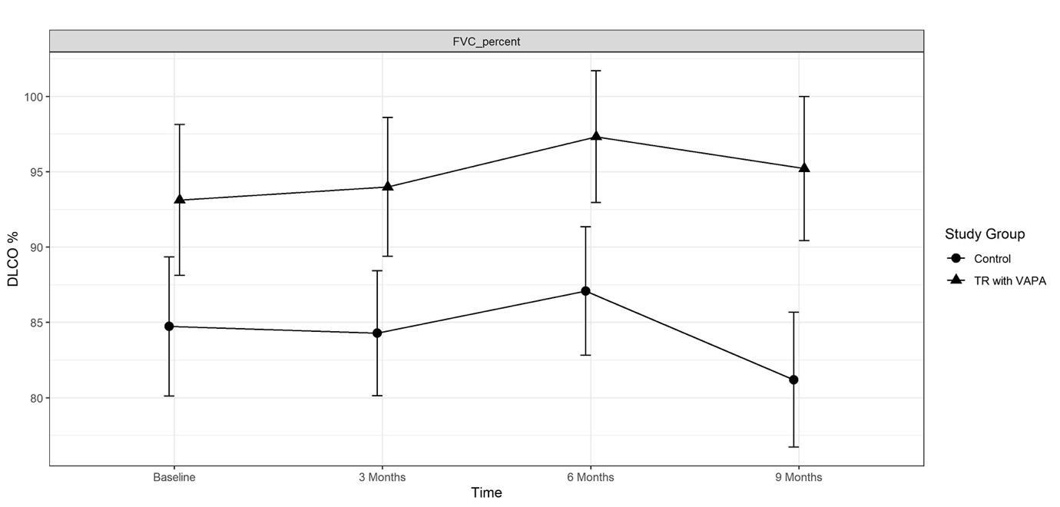
Figure 2. Mean DLCO percent predicted over time for the control and intervention group.
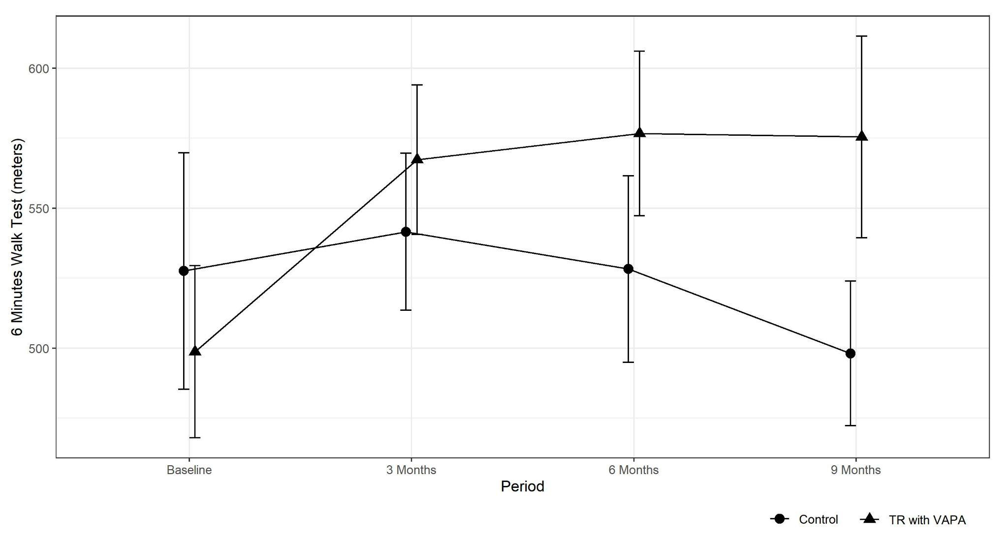
Figure 3. Mean six minute walk test distance in the control and intervention group (meters).

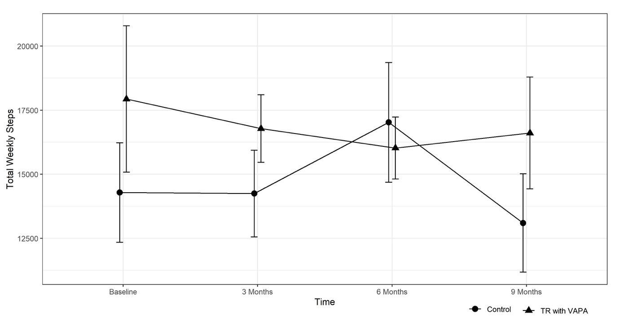
Figure 4. Mean 7 days pedometry over time for the control and intervention group (meters).

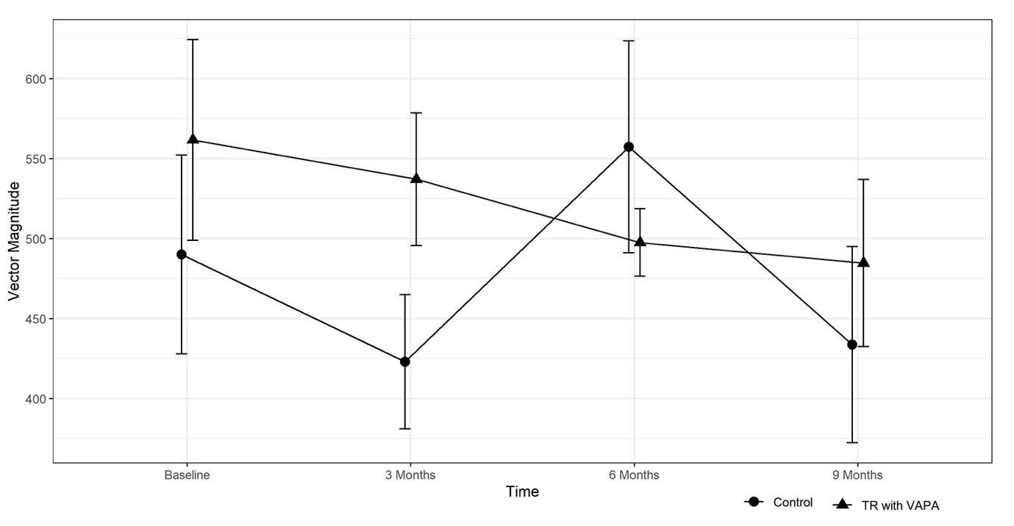
Figure 5. Mean 7 dVMCPM over time for the control and intervention group (meters).
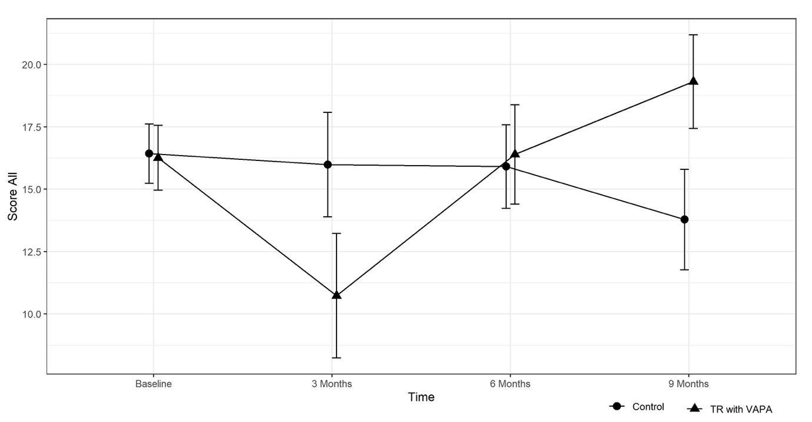
Figure 6. Mean MVC arm & leg total over time for the control and intervention group in Kilogram Force

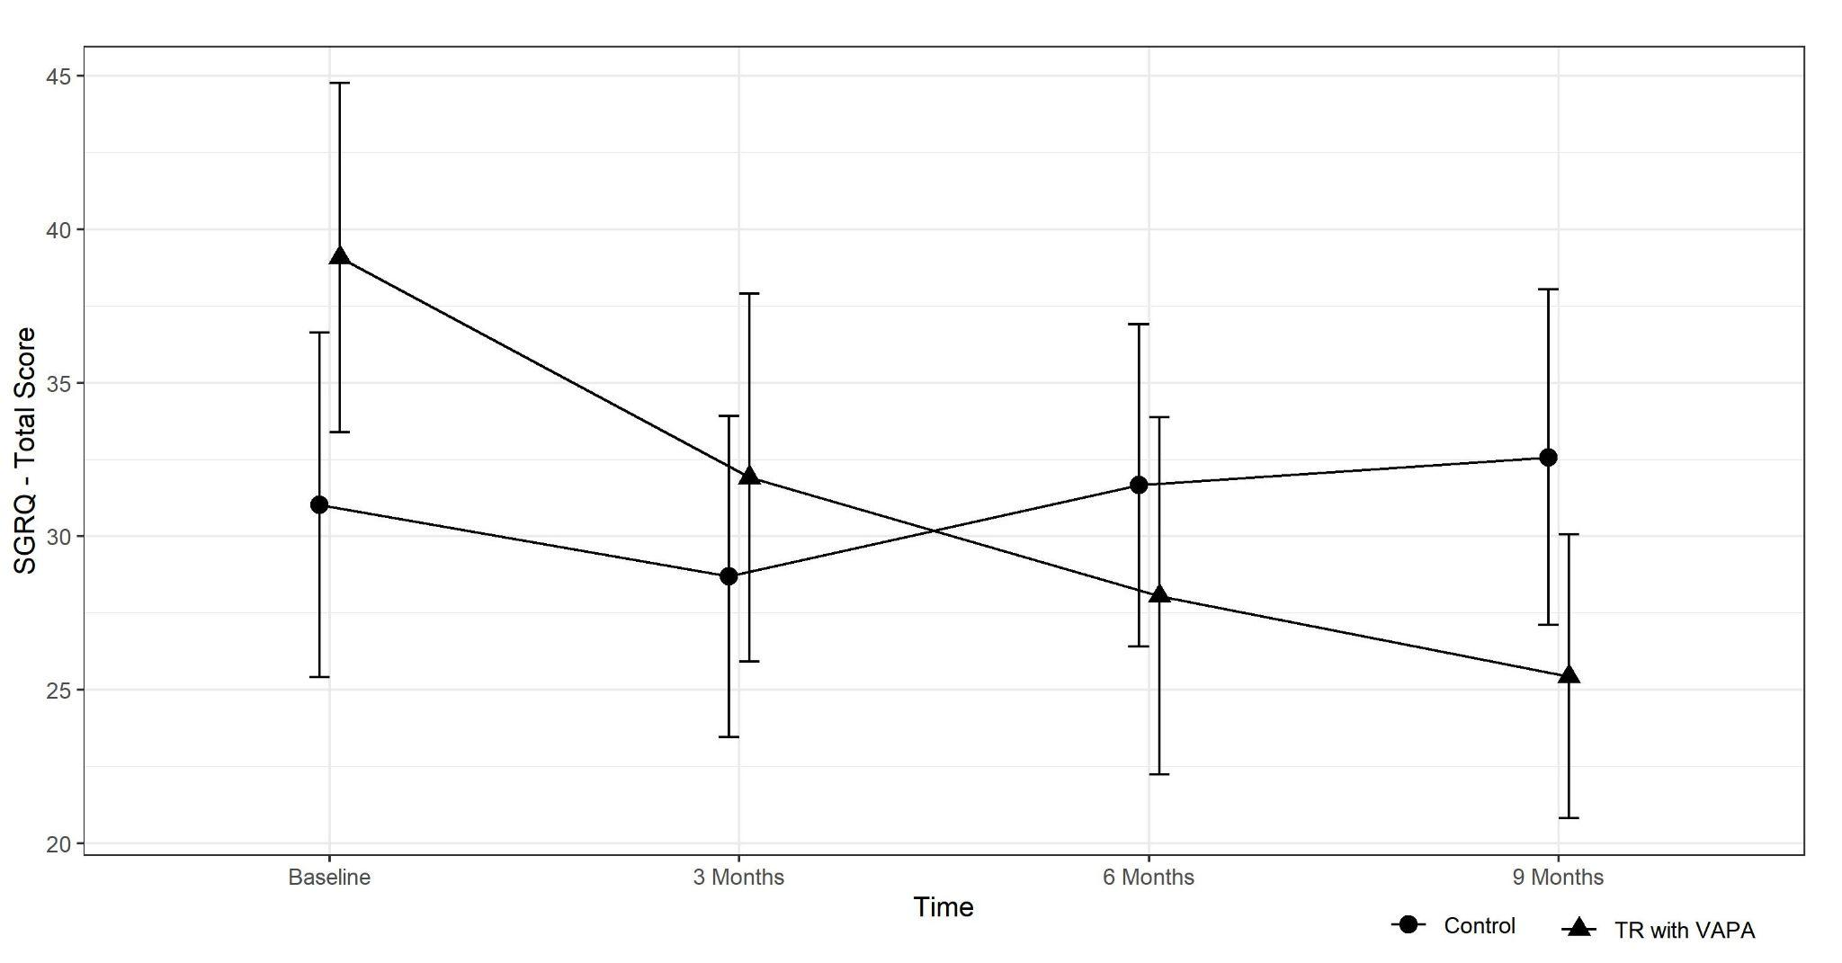
Figure 7. Mean SGRQ total score over time for the control and intervention group.
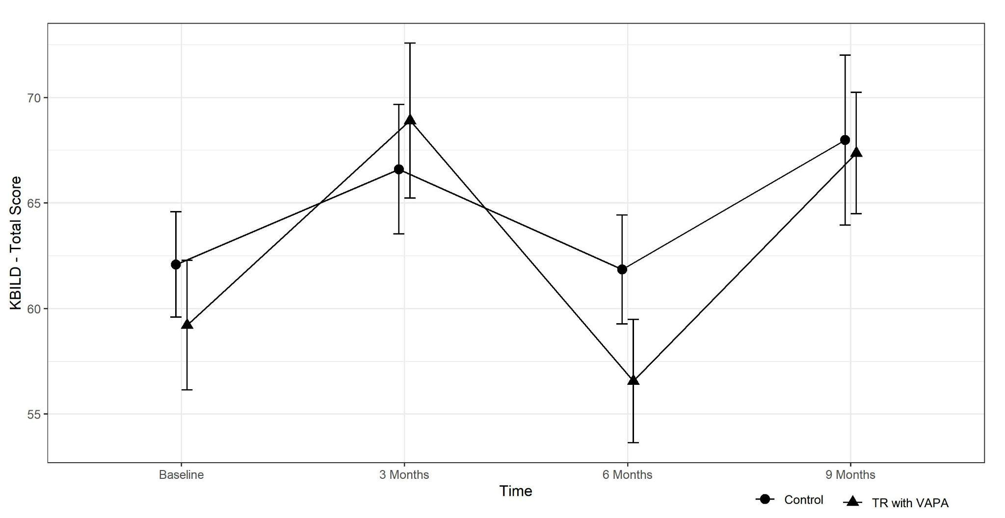
Figure 7. Mean KBILD total score over time for the control and intervention group.

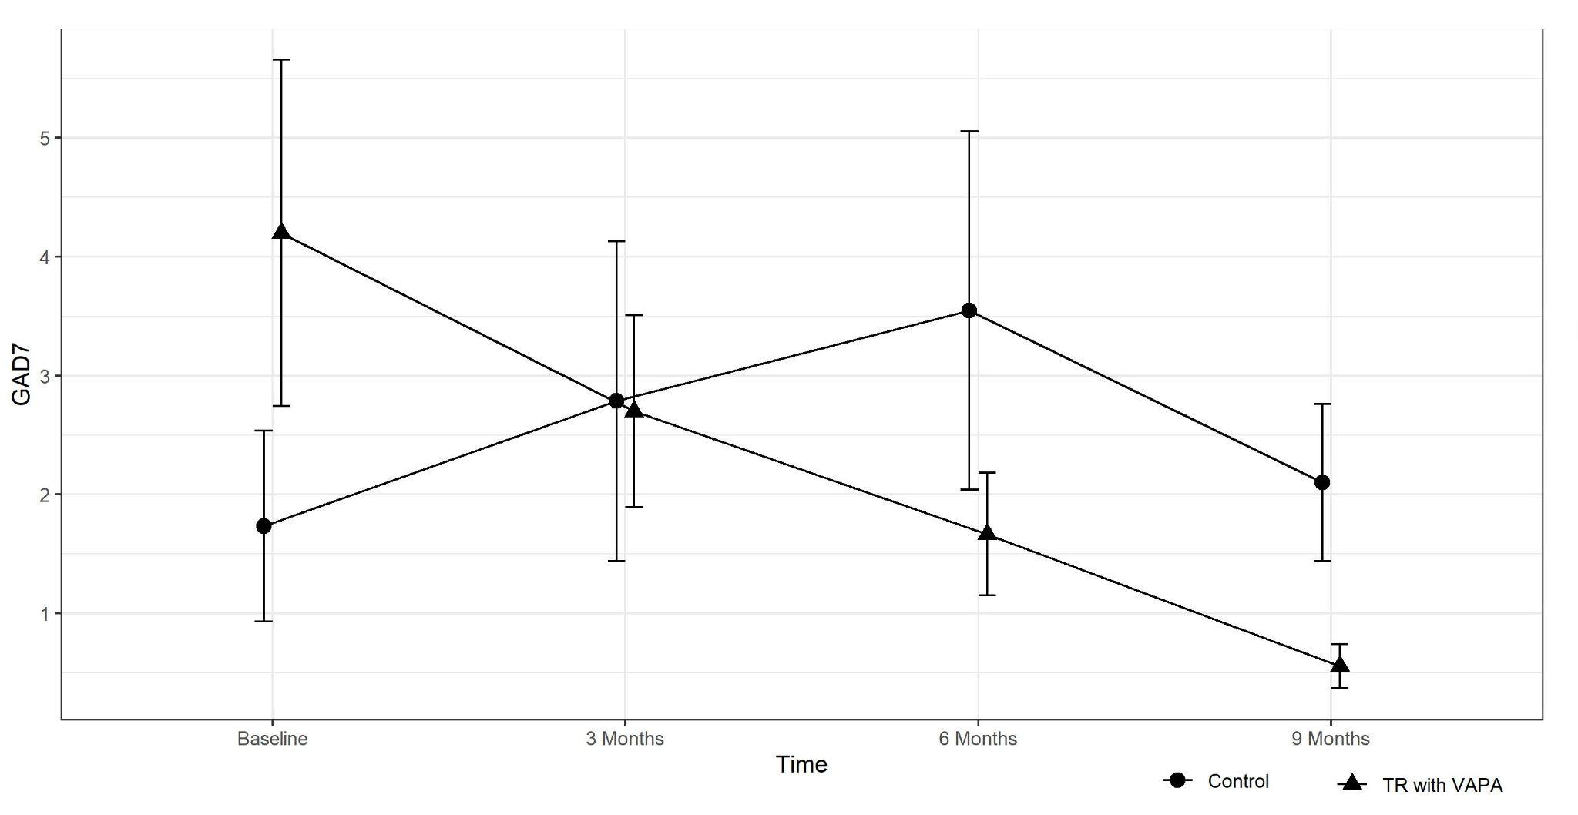
Figure 8. Mean GAD-7 over time for the control and intervention group.

Report 5 (Protocol for maximal isometric voluntary contraction in arm and leg)
STRENGTH TEST (on the dominant arm and leg)

Three consecutive measurements will be performed with one minute intervals between contractions. Isometric muscle force from elbow flexion and extension, knee flexion and extension, and shoulder abduction will be measured.
Subjects will be asked to gradually increase their muscle force to a maximum effort which would need to be sustained for three seconds. The ‘break technique’ will be employed whereby the examiner overpowers the maximum effort of the patient, thereby producing a measurement of eccentric muscle force.
The protocol consists of one contraction for every individual muscle in the following sequence; 1 elbow flexion, 2 elbow extension, 3 knee extension, 4 knee flexion, and 5 shoulder abduction. This sequence will be performed three times on the dominant arm and leg.
Subjects will be asked to gradually increase their muscle force to a maximum effort which would need to be sustained for three seconds. The ‘break technique’ will be employed whereby the examiner overpowers the maximum effort of the patient, thereby producing a measurement of eccentric muscle force.
Unit measurement is kilogram-force (kgf).
 | 1 elbow flexion | 2 elbow extension | 3 knee extension | 4 knee flexion | 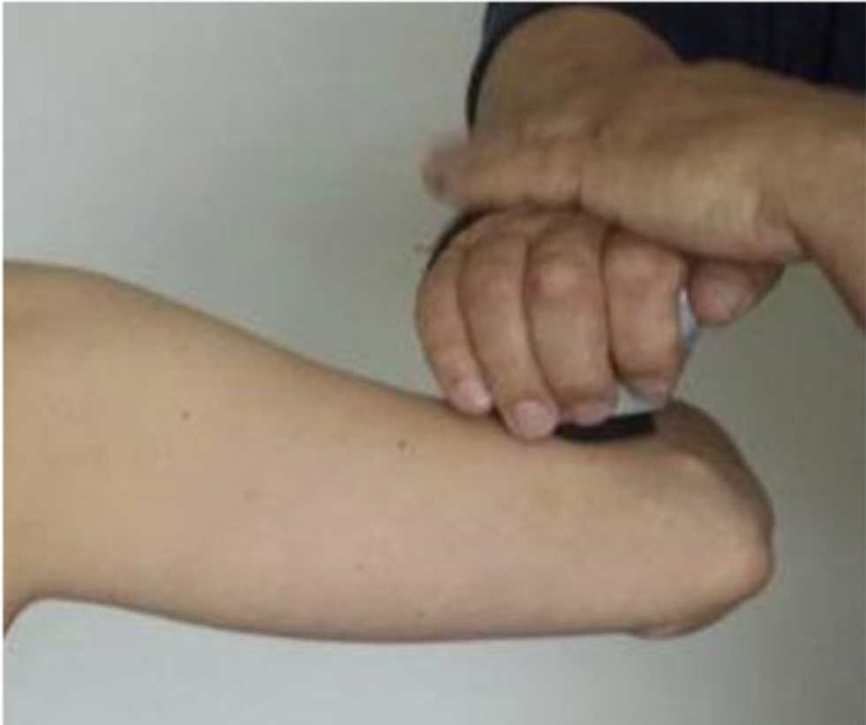  5 shoulder abduction
TRY 1
TRY 2
TRY 3
AVERAGE

AVERAGE ARM | AVERAGE LEG | AVERAGE TOTAL

Report 6 (6 minute walk test distance results occluding the 4 patients with scadding stage 0)

Table 1: Independent test between groups for 6MWT
 | INTERVENTION |  |  |  | CONTROL |  |  |  | Mean Difference | Std. Error Difference | 95% Confidence Interval of the Difference |  | p-Value
 | n | Mean | Std. Deviation | Std. Error Mean | n | Mean | Std. Deviation | Std. Error Mean |  |  | Lower | Upper
Baseline | 8 | 536.63 | 112.13 | 39.65 | 10 | 524.70 | 136.73 | 43.24 | 11.93 | 60.03 | -115.34 | 139.19 | 0.85
3 months | 8 | 557.88 | 115.26 | 40.75 | 10 | 522.40 | 108.34 | 34.26 | 35.48 | 52.85 | -76.56 | 147.51 | 0.51
6 months | 8 | 570.00 | 119.66 | 42.31 | 10 | 506.60 | 112.96 | 35.72 | 63.40 | 54.99 | -53.18 | 179.98 | 0.27
9 months | 8 | 567.38 | 146.80 | 51.90 | 10 | 498.10 | 99.99 | 31.62 | 69.28 | 58.20 | -54.10 | 192.65 | 0.25

Table 2: Pair t test for 6MWT
 |  | Paires |  |  |  | Paired Differences
 |  | Mean | n | Std. Deviation | Std. Error Mean | Mean | Std. Deviation | Std. Error Mean | 95% Confidence Interval of the Difference |  | P-value
 |  |  |  |  |  |  |  |  | Lower | Upper
Pair 1 | 3 months | 538.17 | 18 | 109.60 | 25.83 | 8.17 | 44.53 | 10.50 | -13.98 | 30.31 | 0.45
 | Baseline | 530.00 | 18 | 122.93 | 28.97
Pair 2 | 6 months | 534.78 | 18 | 117.06 | 27.59 | 4.78 | 91.11 | 21.48 | -40.53 | 50.09 | 0.83
 | Baseline | 530.00 | 18 | 122.93 | 28.97
Pair 3 | 9 months | 528.89 | 18 | 124.18 | 29.27 | -1.11 | 84.78 | 19.98 | -43.27 | 41.05 | 0.96
 | Baseline | 530.00 | 18 | 122.93 | 28.97

"Table 1 is from the paper “Tele-Rehabilitation Program in Idiopathic Pulmonary Fibrosis—A Single-Center Randomized Trial" by Cerdan-de-las-heras et al ¹, used under CC BY ² / content modified from original

